PRESS INFORMATION: OVERVIEW OF POLYCLOSE 2024
Ghent (Belgium), January 2024
Looking back on Polyclose 2024 – The platform for innovation
Over 200 exhibitors showcased innovations at the 21st European trade fair for windows, doors, sun protection, façade and access technologies
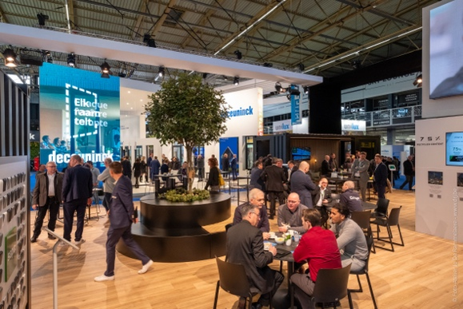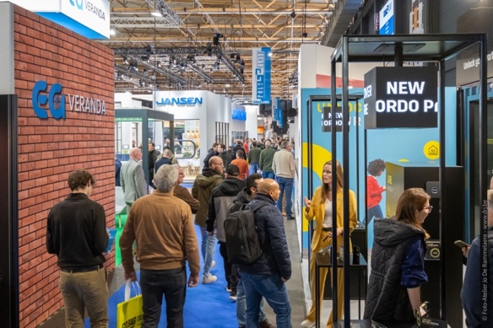
From Wednesday 17 to Friday 19 January, Flanders Expo in Ghent focused on innovation during an impressive 21th edition of Polyclose, Europe’s networking and trade fair for windows, doors, sun protection, façade and access technologies. With over 200 exhibitors and – despite the announced snowfall – as many as 12,108 trade visitors, the event was well-attended, presenting the latest trends and solutions to construction industry challenges. Most of the visitors, of course, came from Belgium. 23% of the professionals present were from the Netherlands.
Surprising number of innovations at well-attended Polyclose 2024. New applications were unveiled for the first time at nicely presented stands and there were numerous live demonstrations for installers. Many of the usual exhibitors were present, but a few newcomers also introduced themselves to the market. The fair revolved around three themes: home comfort, circularity and climate control.
Innovation and sustainability
The fair paid plenty of attention to façade insulation. Sleek and slender window profiles remain very popular and manufacturers are doing all they can to allow these to meet insulation, ventilation and installation challenges. Within the door industry, burglary prevention remains an important focus alongside insulation, draught exclusion and aesthetics.
Manufacturers of façade elements are making increasing use of films to ensure the desired appearance or characteristics. Besides films to improve aesthetics and durability, several exhibitors also presented sun protection, soundproofing and even anti-burglary films. Green façades are more and more popular as well.
Sun protection has increased greatly in prominence in the façade industry in recent decades, and thus also at Polyclose. Various sun protection systems were on display at the fair, with many allowing for automatic control through natural energy sources such as solar energy.
Manufacturers and suppliers to the windows, doors and façades market were present as well. Software solutions to support manufacturers of windows, doors, blinds and façades could also be found at the fair, as could machine manufacturers.
Internationalisation
Once again, Polyclose confirmed its position as an international platform made to measure for the windows, doors, façades, blinds and access technology industries. The presence of exhibitors and professionals from multiple countries served to illustrate the industry’s internationalisation.
In the words of Guy Martens, the fair’s founder: “Of course we are extremely pleased and thankful to have so many European exhibitors and visitors find their way to Polyclose once more. More than that, however, we are proud of the excellent networking opportunities. The fair surely provided attendees with ample business opportunities to be used to their advantage in the next two years.”
Next edition: 14-15-16 January 2026
The various innovations and sustainability solutions on show stand as proof of this industry’s continuing development. In light of the most recent edition’s success, the fair’s organisers look forward eagerly to the upcoming edition on 14, 15 and 16 January 2026 (with evening opening on Thursday) in Ghent. “The event once again proved an important place to meet for professionals concerned with this industry’s development and advancement,” Guy Martens said. “Moreover, the industry continues to face many challenges with regard to sustainability and construction projects are increasingly complex. This calls for greater collaboration between the various parties and disciplines. Polyclose is happy to do its part in bringing together players from the world of windows, façades, doors, sun protection and access technologies in 2026.”
Mark the dates on your calendar: 22th Polyclose on Wednesday 14, Thursday 15 and Friday 16 January 2026 at Flanders Expo in Ghent. Interested exhibitors can already register: info@polyclose.be
More information is available at www.polyclose.be
*** NOT FOR PUBLICATION ***
Photos:
Go to www.polyclose.be to download photos of the 2024 edition.
(via Press – Visual Material)

Press contact:
Kurt Peeters, Polyclose Press Officer
M +32 (0)474 444 660, press@polyclose.be
Organisation of the fair:
LIMACO NV, Maaltebruggestraat 300, 9000 Ghent, Belgium
T +32 (0)9 245 06 46
www.polyclose.be

